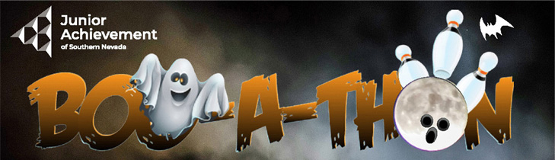
Date
FOR IMMEDIATE RELEASE
For Photos: https://www.dropbox.com/scl/fo/58j2mkonhl2jr3fx2xdnc/h?rlkey=glh7tp5xrl1zrh3efve1cv29s&dl=0

Boo-A-Thon Bowling Tournament Returns for
Junior Achievement of Southern Nevada

A fun lead-up to Halloween, Junior Achievement of Southern Nevada is hosting its Boo-A-Thon Bowling Tournament on Oct. 14 and Oct. 15, 2023, at the Santa Fe Station Bowling Center. Teams play options are from 2 p.m. to 4 p.m. on Saturday or noon to 2 p.m. or 3 p.m. to 5 p.m. on Sunday.

"The Boo-A-Thon is a great company team-building activity that helps us raise needed funds in a fun way to support financial literacy, workforce readiness and entrepreneurial programs for more than 20,000 K-12 students," said Michelle Jackson, president and CEO of the nonprofit Junior Achievement of Southern Nevada. "This Halloween-themed event has always generated a lot of laughs and friendly competition for company teams and also family and friend groups, and has been successful for Junior Achievement."

During the Boo-A-Thon, participants can show off their bowling tricks and treats. Teams are comprised of five people, with each participant raising at least $100 per person, and costumes are encouraged. Prizes will be awarded for the best team and individual costume, lane decoration, top individual bowler, and top individual and team fundraiser. Participants also can purchase raffle tickets for other prizes.

There is a $20 registration fee for all bowlers, which includes unlimited bowling for two hours, shoes, pizza, soda, and prize opportunities. Bowlers can register their teams at
Bit.ly/3OSzqZr. Once a team has registered, participants can create their individual and team fundraising pages.

Junior Achievement will provide fundraising tools to help individuals and teammates reach and exceed donation goals.

A variety of Boo-A-Thon sponsorship opportunities are still available, starting at $500.
Current sponsors are: Nevada State Bank, RSM, City National Bank, Barclays, Cragin & Pike, KPMG, PSI Seminars, Leadership Las Vegas, Diversified Restaurant Group (DRG) and Purdue Marion and Associates.

The Santa Fe Station Bowling Center is located at 4949 N. Rancho Road.
For more information about the Junior Achievement Boo-A-Thon, visit JA 2023 BOO-A-THON | Junior Achievement of Southern Nevada or contact Will Abbott at will.abbott@ja.org.

About Junior Achievement of Southern Nevada
Junior Achievement of Southern Nevada, Inc. is dedicated to providing financial education to K-12 students with age-appropriate virtual and live curriculum that spans from budget management to economic principals, workforce skills and credit. Founded locally in 1996, the local nonprofit organization has reached more than 450,000 students in the Las Vegas area with the help of 285 businesses and 6,800 business role models. For more information, visit https://southernnevada.ja.org/ and follow on Instagram and Facebook.

# # #
Media Contacts:
Will Abbott, Junior Achievement of Southern Nevada, will.abbott@ja.org or (702) 888-0519
Nancy Katz, Purdue Marion & Associates, nancy@purduemarion.com or (702-349-0063)

